Lee Taylor

2016 Output: 2015 Output: 2014 Output:

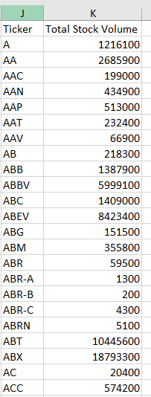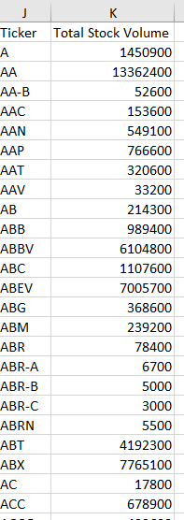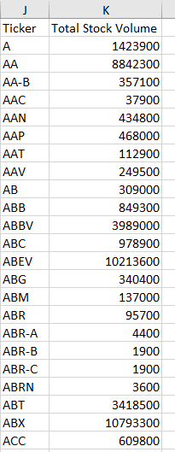

**Code:**

Sub AnnualVolume()

'---------------------------

'Loop Through all Worksheets

'---------------------------

For Each ws In Worksheets

'-----------------------------------------------------

'Volume Totaling

'-----------------------------------------------------

'Set an initial variable for holding the ticker symbol

Dim Ticker As String

'Summary table row creation

Dim Sum_table_row As Integer

Sum_table_row = 2

'Determine last row

LastRow = ws.Cells(Rows.Count, 1).End(xlUp).Row

'Creates summary table headers

Dim symbol As String

Dim Volume As String

symbol = "Ticker"

ws.Range("J1").Value = symbol

Volume = "Total Stock Volume"

ws.Range("K1").Value = Volume

'--------------------------

'Loop Through all datasets

'--------------------------

For i = 2 To LastRow

Dim Ticker_Volume As Double

Ticker_Volume = 0

'Check to see if it is the same ticker

If ws.Cells(i + 1, 1).Value <> ws.Cells(i, 1).Value Then

'Creates the Ticker

Ticker = ws.Cells(i, 1).Value

'adds volume to total

Ticker_Volume = Ticker_Volume + ws.Cells(i, 7).Value

'Prints the ticker into desired range

ws.Range("J" & Sum_table_row).Value = Ticker

'Prints the volume into desired range

ws.Range("K" & Sum_table_row).Value = Ticker_Volume

'adds one to the summary table rows

Sum_table_row = Sum_table_row + 1

'Resets the Ticker Volume

Ticker_Volume = 0

'If the next cells is also the same ticker add to total volume

Else

Ticker_Volume = Ticker_Volume + ws.Cells(i, 7).Value

End If

Next i

Next ws

'Formats the Columns to desired fit

With Worksheets("2016").Columns("J:K").AutoFit

End With

With Worksheets("2015").Columns("J:K").AutoFit

End With

With Worksheets("2014").Columns("J:K").AutoFit

End With

MsgBox ("Complete")

End Sub